Air Composition Pie Chart Worksheet

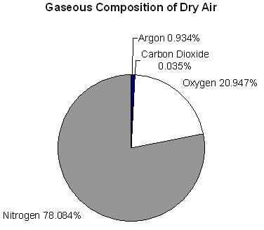

**Gaseous Composition of Dry Air**

|  |  |
| --- | --- |
| **Gas** | **Percentage** |
|  |  |
|  |  |
|  |  |
|  |  |
| **Total** |  |